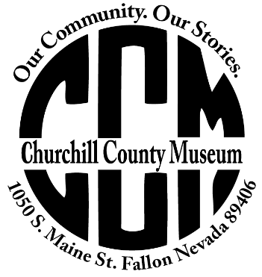
  - Volunteer Questionnaire Form
  - Churchill County Museum and Archives
  - 1050 S. Maine Street
  - Fallon, Nevada 89406
  - (775) 423-3677

Do you have a desire to assist the Churchill County Museum? Want to become part of our museum family? Please complete and return this form. Understand that while we strive to match volunteers to their passion, there often are projects that need assistance that may not be within your desired fields.

Name: ________________________________ I would like to volunteer on a regular basis.
Address: ________________________________ I prefer project specific opportunities.
________________________________ I can begin volunteering: ____________________
Home Phone: ________________________________
Work Phone: ________________________________

Tell us about yourself:

I can climb a ladder of 5-6 feet I have reading & writing skills
I can lift between 5 -20 pounds I can tolerate dust
I have research skills I write legibly
I can work independently I have computer skills
I have data entry skills I have archival experience
I enjoy working with people I have a love of history
I enjoy working with children I have a willingness to learn
I will wear a costume for programs I have general construction / handyman skills
I can use hand and power tools I can mend textiles
I am skilled with a photo scanner

Do you have job experiences and outside interests that might apply to museum work?

Thank you for completing the volunteer questionnaire. Please sign and date and we will contact you
for a volunteer interview.

Signature: _____________________________________ Date: _________________________

